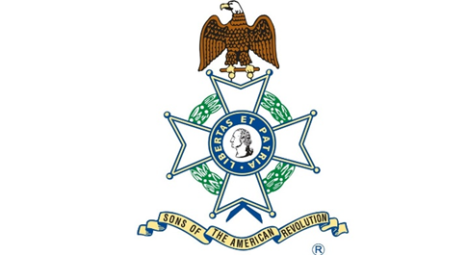

Isaac Mayfield

Born about 1755

Died 1794

Illinois

General George Rogers Clark, Illinois Regulars.

3rd Great Grandfather of Joe Edward Bostick

Isaac Mayfield served as a Private in Gen. George Rogers Clark's Illinois Regulars in the summer of 1778 when the Virginia Troops marched through the wilderness to the Northwestern Territory. There, they surprised the British at Kaskaskia Illinois) and continued to also capture Ft. Sackville (Vincennes, Indiana).

Isaac Mayfield was killed by Indians in Tennessee in 1794.

References: The Virginia Magazine of History and Biography, October., 1893, Vol. 1, No. 2 (Oct., 1893), pp. 127-141

