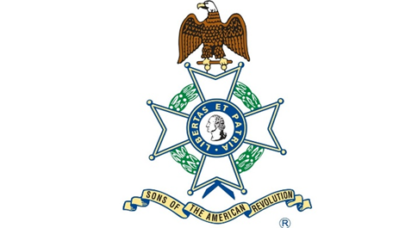

Thomas Blair

Born Abt 1739

Died August 10, 1825

North Carolina

Immigrating to Lancaster PA, Patriot Thomas Blair (P-115806) was a farmer who served in the War for Independence as a Major with the Guilford Militia in North Carolina. He fought at the Battle of Moore’s Creek Bridge & Guilford Court House.

