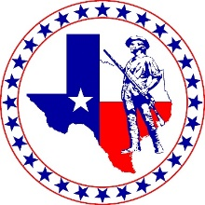 | 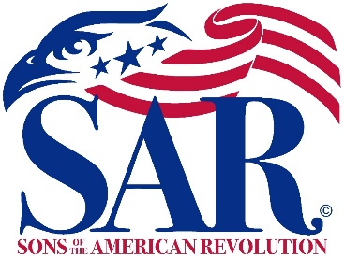 | 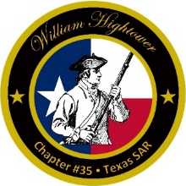

William Hightower Chapter
Texas Society, Sons of the American Revolution
Patriotic-Historical-Educational

Meeting Agenda
10 Nov, 2022
Social Hour: 5:30 p.m. Business: 6:30 p.m.
Granzin Bar-B-Q, New Braunfels

- Invocation
- Pledges to the Flags
  - Pledge of Allegiance
  - Texas State Pledge
  - SAR Pledge
- Introduction of Guests
- President’s Welcome and Comments
- Inductions of
- Officer and Committee Reports
- Speaker: former President General Ed Butler
Topic: “El Cazador, the Spanish treasure ship that changed the destiny of the world”
- Next Meeting
8 Dec Nov, 2022, Social Hour 5:30 p.m., Business 6:30 p.m.
At Montana Mike's Steakhouse
- Benediction
- SAR Recessional

