 | 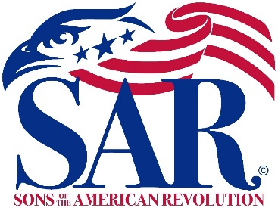 | 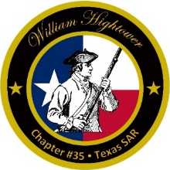

William Hightower Chapter
Texas Society, Sons of the American Revolution
Patriotic-Historical-Educational

Meeting Agenda
9 Feb, 2023
Social Hour: 6:00 p.m. Business: 6:30 p.m.
Granzin Bar-B-Q, New Braunfels

- Invocation
- Pledges to the Flags
  - Pledge of Allegiance
  - Texas State Pledge
  - SAR Pledge
- Introduction of Guests
- President’s Welcome and Comments
- Officer and Committee Reports
- Inductions
- Guest Speaker: Stu Hoyt, topic “George Washington And the Challenge Within.”
- Next Meeting
9 Mar 2023, Social Hour 5:30 p.m., Business 6:30 p.m.
At Granzin Bar-B-Q
- Benediction
- SAR Recessional

